**Practical No.3**

Random Variables and Distribution Functions.

Name: Neeraj Sanjay Shah

Roll No: 51

Class: F.Y. Data Science

Sub: Probability & Distribution

Sign:

**Aim: To compute the expected value, variance, standard deviation and CDF**

Q.1 Three coins are tossed simultaneously. X is the number of heads. Find the expected value and variance of X.

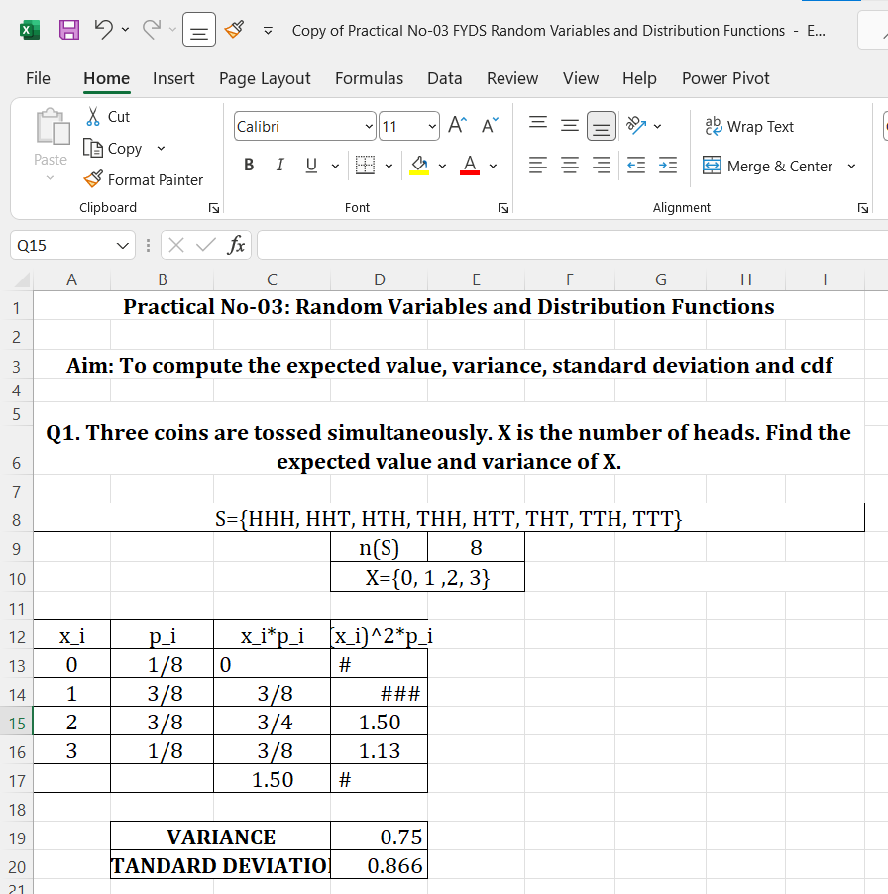

Q.2 Let two dice be thrown and the random variable X be the sum of numbers on the upper face of dice. Find the mean, variance and standard deviation.

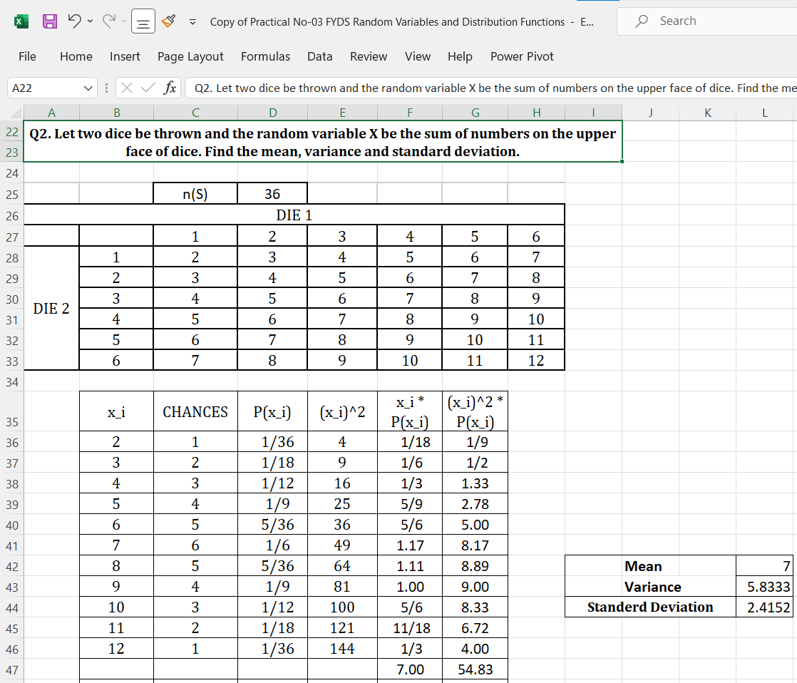

Q.3 Consider the following probability distribution:

